Mini DnD

Ciara Jones

University of Missouri – Kansas City

Table of Contents
Vision Statement 3
Requirements 4
Product Backlog 5
Sprint #1 6
Review 6
Retrospective 6
Sprint #2 7
Review 7
Retrospective 7
Sprint #3 8
Review 8
Retrospective 8
Sprint #4 9
Review 9
Retrospective 9
Sprint #5 10
Review 10
Retrospective 10
Sprint #6 11
Review 11
Retrospective 11

Vision Statement
My program will be a small version of a dungeons and dragons game. Some key features I want to add are the different types of die, various character stats, opponents to fight, and different types of attacks. In a normal game of DnD, the various types of die in a set include a d20, d12, d10, d8, d6, and a d4. All of these are used to make different roles depending on how you want to play. The roles could be for attacks, spells, healing, and others. There are various characters that can be created by the user to be played in a game. There are too many combinations of character races and classes to program them all. My goal is to add a few races and classes and let the user decide the combination they want to play. Every game of DnD needs opponents to fight. A player can fight opponents using weapons or spells depending on what their character traits are. To fight the different opponents, the player will need different types of attacks, spells, healing, etc. to win. I am hoping to add some elements of a storyline to the game as well. With elements of a storyline, the player can solve problems in various ways apart from combat, since there are various scenarios that don’t involve combat in a game of DnD. My plan is to start with designing ways to create characters, creating opponents for the player to fight, assigning stats for both the user and the opponents, and specific attacks for both the user and the opponents initially. Creating a storyline and other scenarios to play are what I hope to program later into development.

Requirements
A discussion of what your application is required to have in functionality. It should identify user roles and goals/actions, and what the key features of the app should be.
Actor | Goal
Gameplay | Use different die for different user decisions
Player | Assign stats to the user’s character based on the user’s choices
Opponent | Design opponents for the user to fight
Player | Assign different classes and or races for a user to pick
Gameplay | Assign different ways to attack depending on the race and class of the user
Player | Design easy ways for the user to make a character
Gameplay | Design ways to measure health for both the user and opponents
Opponent | Design a way to show combat between the user and opponents
Player | Design an outcome if the player wins and loses
Gameplay | Design a short storyline for the player
Player | Design a way for the player to see their stats and health
Gameplay | Display the outcomes of die roles

Product Backlog
This will be updated throughout the semester as new PBIs are added, larger items are broken into smaller ones, and completed items removed.

Story ID | Story | Story Points  (in est. hours) | Priority | Status
5 | As a player, I want to be able to create a character, so that I will play the game the way I want to | 8 | - | Done
10 | Assign stats based on the character the player creates | 5 | - | Done
25 | As a player, I want a way to see my health and how it changes throughout the game | 5 | - | Done
15 | Design opponents for the player to fight | 5 |  | Done
20 | As a player, I want specific attacks that go with my character choice, so that I can use them against opponents | 5 | 1 | Started
30 | As a player, I want a game with a plotline | 7 | 2 | Started
35 | As a player, I want to see the outcome of my die roles | 4 | 3 | Not Started

Sprint #1

Sprint Backlog
Story ID | Story / Task | Estimated  Hours | Actual  Hours
5 | Create character options | 4 | 3
5 | Design ways to design character | 4 | 2
10 | Assign stats per user choice | 2 | 1
10 | Design way to show user stats | 3 | 1
15 | Design opponents for the user to fight | 3
15 | Design ways for the opponent to fight | 2
20 | Create attacks for the user based on the created character | 5

Review

For this sprint I was hoping to get the character design section, stats for each character, opponents, and attacks for the player. But, I created the character design section and started the stats for the player section. I have not finished the stats for player section of the game, creating opponents for the player to fight, a way for the player to fight opponents, and attacks for the player based on the character built.

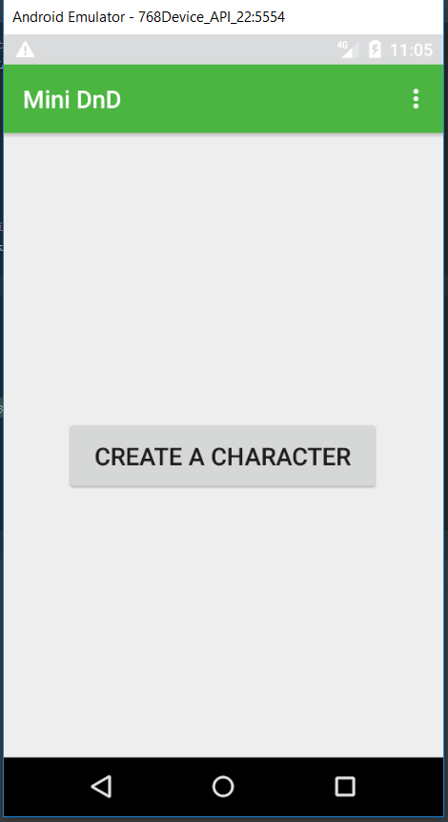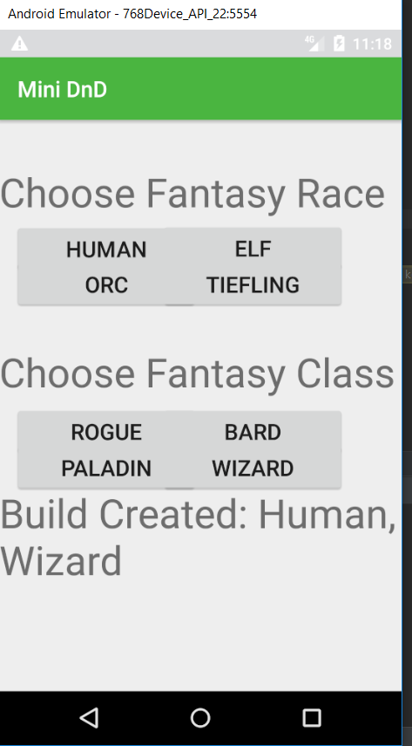

Retrospective
During this sprint, creating the page for the player to choose the traits for their character went well. There are many different combinations of possible character builds in a real game of DnD so I chose four races and four classes to simplify the process. I plan to continue to find simplified versions of DnD aspects. What did not go well was my time planning. I did not make myself enough time to write the code needed to accomplish everything I wanted to. I plan to try and make more time in my schedule and decrease the workload of each coming sprint. I estimated a total of 23 hours of work needed for this sprint, and I accomplished 7. I need to keep in mind my other obligations when planning sprints.

Sprint #2

Sprint Backlog
Story ID | Story / Task | Estimated  Hours | Actual  Hours
10 | Assign stats per user choice | 3 | 3
10 | Design way to show user stats | 3 | 4
15 | Design opponents for the user to fight | 3 | 2
15 | Design ways for the opponent to fight | 3
20 | Create attacks for the user based on the created character | 5

Review
During this sprint I added a page to show the player their stats based on the character they choose to create. It can be accessed from the upper menu. I also added some error handling in case the user doesn’t confirm their character choice or tries to start the game without a character build. I have added a class to assign different enemy types different stats. It ranges from easier enemies to more difficult ones.
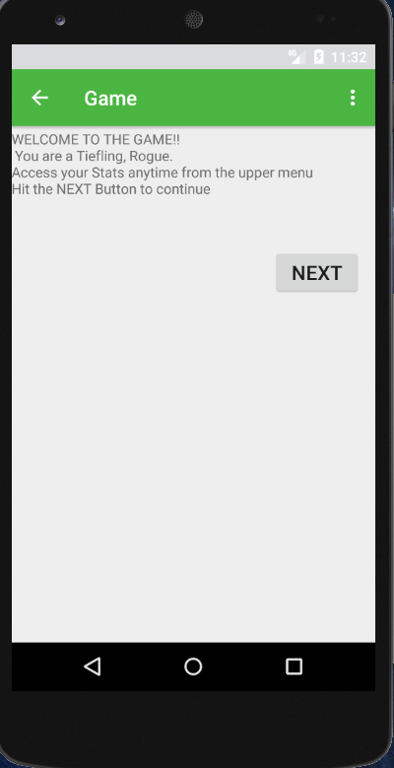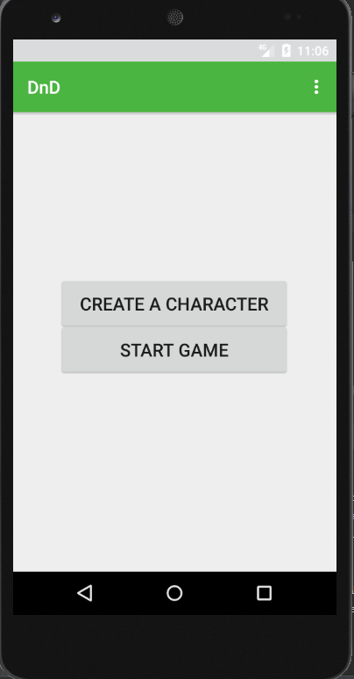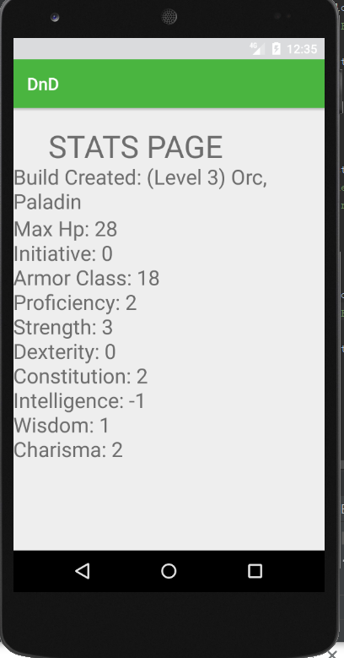

Retrospective
During this process, creating the stats page based on the character build was difficult to try to create. I wanted it to be opened whenever the user chooses to access it. For each of the possible character combinations I used a randomized DnD character sheet to be preassigned stats. I did the same for the enemy stats as well. I thought it would be the easier choice than having the player roll their own stats. I tried to plan more time in my schedule for writing and planning. Some of the tasks that I planned took longer than I expected or adding new sections of code added more potential errors that I needed to find a way to fix. Even though I didn’t complete every task that I planned for this sprint, I think I have made major progress to my project and learned more about how Android Studio and Java works. I plan on using this new knowledge to help in the next sprint.

Sprint #3

Sprint Backlog
Story ID | Story / Task | Estimated  Hours | Actual  Hours
15 | Design ways for the opponent to fight | 3
20 | Create attacks for the user based on the created character | 5
25 | Design a way for the player to see their up to date health | 4 | 3
30 | Create a plot line for the game to follow | 7 | 3

Review
During this sprint I added a health bar to show the user how their health changes throughout the game. The max of the progress bar will change according to what the player’s stats are. I also started on the plotline for the game. When the user hits the next button, the game will cycle through the game. The first enemy will be decided from a random dice roll from 0-4.
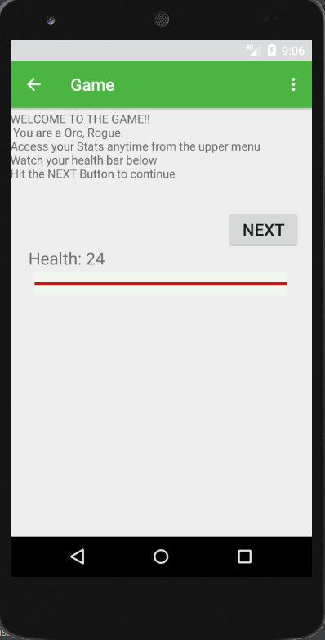

Retrospective
During this sprint, creating the health bar went easier than I initially thought. I found that using a progress bar would the easiest way to create it. I could set the max according the different max health stats of the user. I also put the health of the user in a numeric value to make it easier to read. I came up with a few ideas for how to simulate combat between the enemies and the user and I am having trouble deciding which would be the better option. I want the solution to be simple but also still be fun for users to play. I plan on adding the solution in the next sprint. I also plan on added more to the plotline of the game. Finding the best way to cycle through the story of the game was difficult, but now that I have found a way to accomplish this I will add more to the plotline of the story in the next sprint.

Sprint #4

Sprint Backlog
Story ID | Story / Task | Estimated  Hours | Actual  Hours
15 | Design ways for the opponent to fight | 4 | 2
20 | Create attacks for the user based on the created character | 5 | 5
30 | Create a plot line for the game to follow | 5 | 1
35 | Display the outcome of user die roles | 4

Review
During this sprint, I added spell attacks to the Stats Page for each combination of build the user could create, an inventory button, a fight button, and a flee button. When the user reaches a point in the plot where combat could happen, the next button will be removed, and the three option buttons will appear. When the user clicks the fight button, the user’s attacks will appear. I have also added attacks to each of the possible enemies.

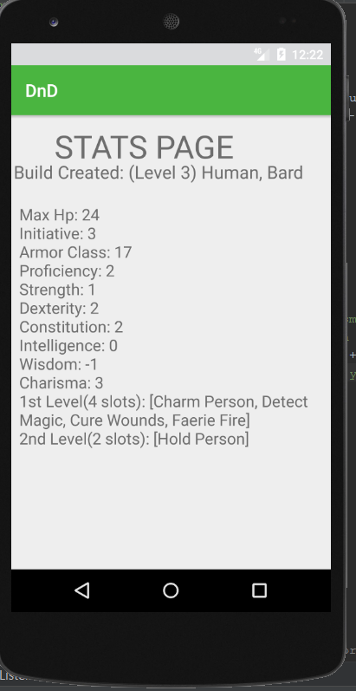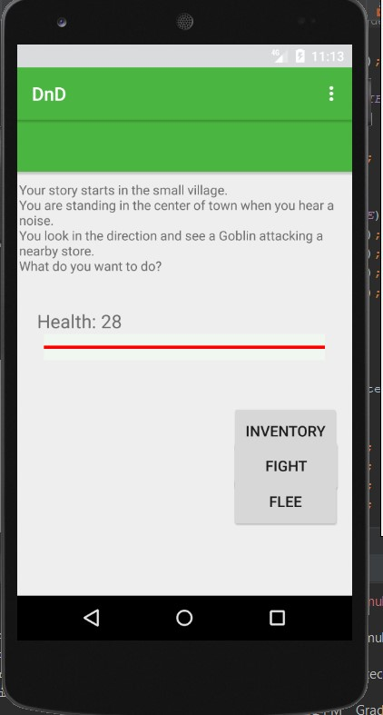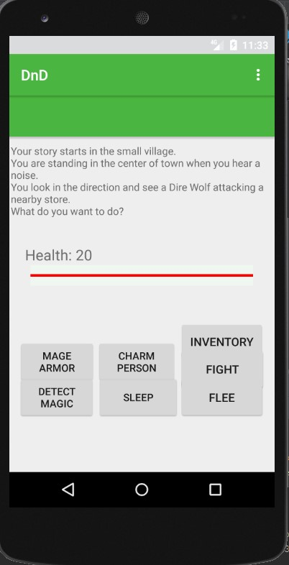

Retrospective
During this sprint, finding a way to add a list of possible attacks per user combination was difficult. I found that using an ArrayList was the best way to accomplish this goal. Once a found a way to accomplish this, added a similar list for the enemies was easier. One problem I found a solution for was changing the text for each of the buttons to match an attack that belongs to the user. For the next sprint, I plan on adding an outcome to the user deciding to flee, adding items to an inventory for the user, and adding a few more options to the attack buttons that appear when the fight button is pressed. Regarding an inventory, I want the user to have a few items that may assist them in the plotline of the game. I also plan on adding dice rolls that will change depending on what the user decides to do and add more to the way enemies can fight. I also have an idea of adding allies to help in combat, but I am deciding on if I want to implement this and how.

Sprint #5

Sprint Backlog
Story ID | Story / Task | Estimated  Hours | Actual  Hours
15 | Design ways for the opponent to fight | 2 | 3
20 | Create attacks for the user based on the created character | 2 | 3
30 | Create a plot line for the game to follow | 4
35 | Display the outcome of user die roles | 4

Review

During this sprint I added to the inventory, fight, and flee features, added a way for the opponent to fight the player, a class to handle the visibility needed for the different aspects of the program, and started on a way for the user to attack. If the use decides to access their inventory, they can see the items they currently have and have the option to use a health potion. If the user’s health is at the maximum amount or they are out of health potions the user will be told so. If the user decides to fight, they will be given the choice of using a first level, second level, or melee attack. If the user decides to flee, the opponent will be given the ability to attack. With the different user options, not all buttons and textviews are needed for every action the user may make. The Util.java class is meant to set the visibility to what is needed. I also added code to the Enemies class to give opponents to ability to attack.

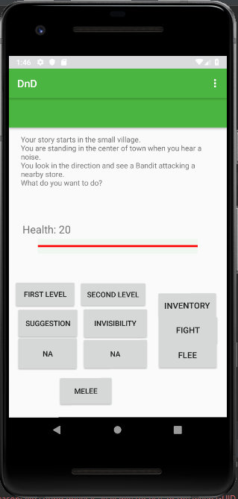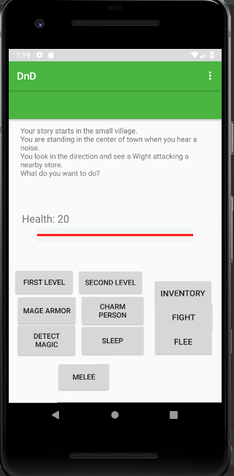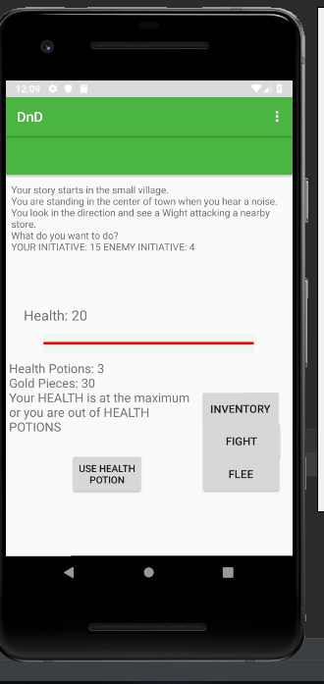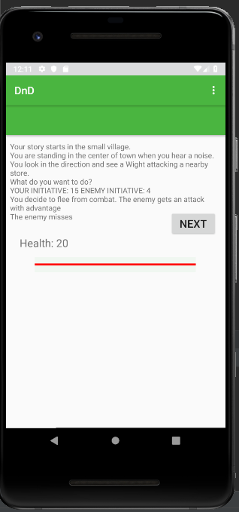

Retrospective
Creating setting the visibility for each of the different user actions was becoming complex so I thought adding a separate class file would simplify the process and make it clear to see what would be happening for each process. I separated different functions based on the need for it. Such as the inventory button, fight buttons, and flee button. Adding a way for the opponent to attack was more complex than I originally thought it would be. I had to find a way to add the different attack rolls based on the opponent and the specific attacks that go with them. Adding separate functions to the Enemies class seemed like the easiest way to accomplish this. For the next sprint, I think adding a way for the user to attack is going to be difficult. Along with this, I to make a precise plan for how the plot of the game will continue in the next sprint. If I decide to add allies, I think adding a class for it would make the process simpler. I am also thinking about adding a way for the player to spend money and possibly earn money in the game.

Sprint #6

Sprint Backlog
Story ID | Story / Task | Estimated  Hours | Actual  Hours
20 | Create attacks for the user based on the created character | 3
30 | Create a plot line for the game to follow | 4
35 | Display the outcome of user die roles | 3

Review

[Screenshots, etc go here. This is where you discuss the product, describing what was done this sprint (potentially shippable product increment) and what was planned for the sprint but was not done. ]

Retrospective
[This is where you discuss the process. What went well (and are you planning to do more of that?) What didn’t go so well (and do you have a way to do less of that)? What changes are you planning to make in how you plan & carry out the next sprint?]

